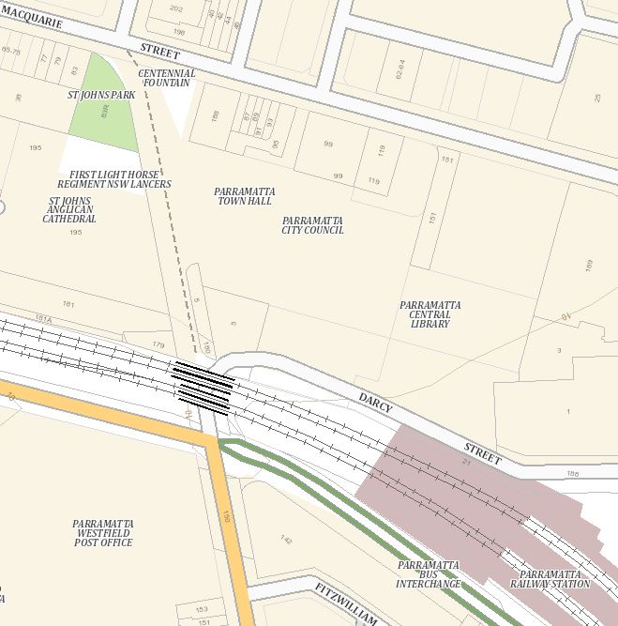
1
2
3
4 & 5
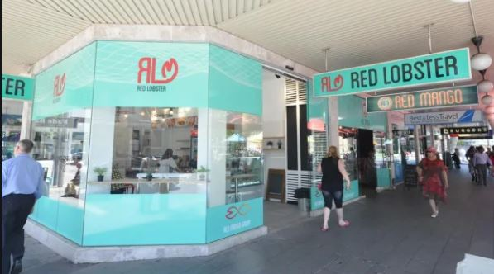
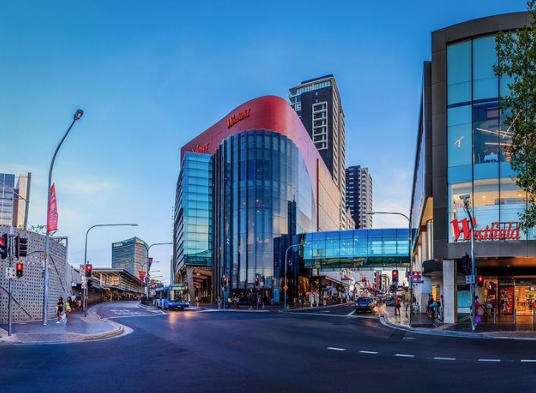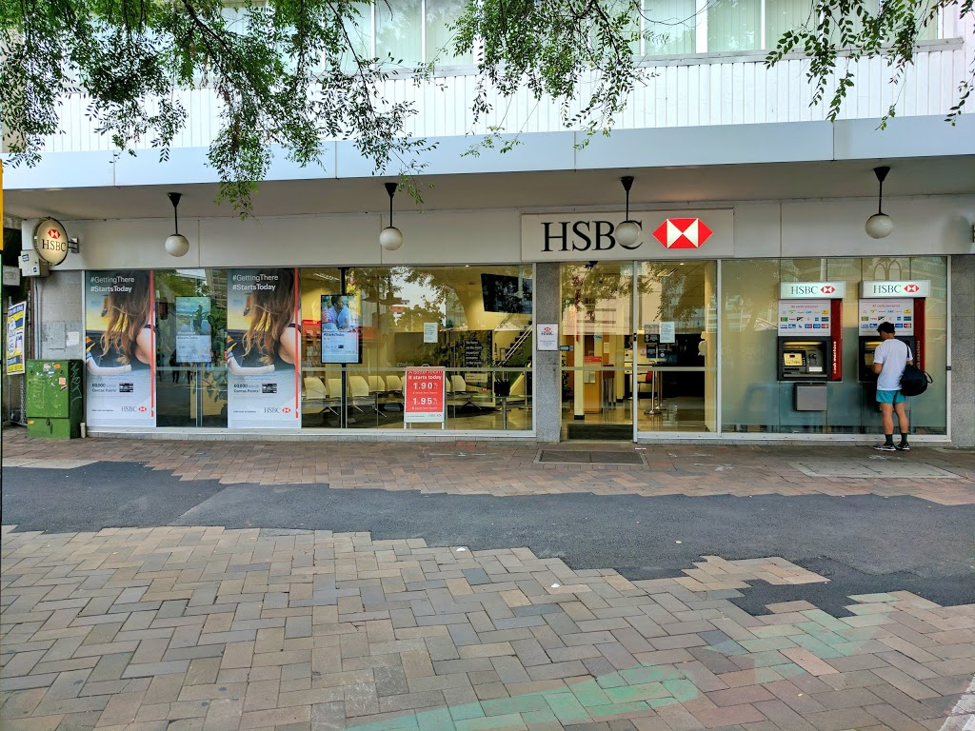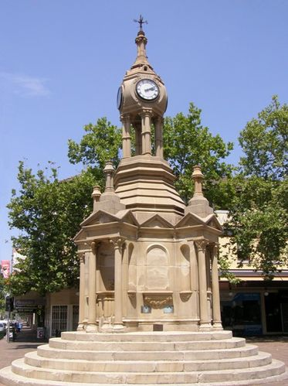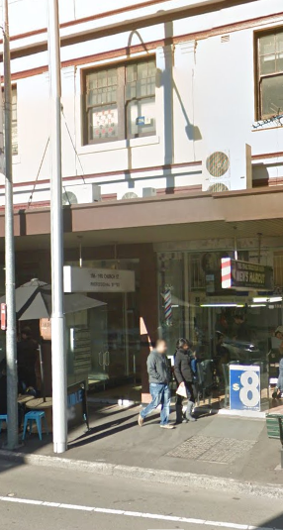
1) Exit at cnr Church and Argyle st 2) HSBC bank 3) Parramatta Centennial 4) Red lobster café 5) Enterance of 186
Memorial Clock Church St
By Car:
Park your car at Westfield Parramatta (Figure 1.), please use the exit at the corner of Church and Argyle street. The exit is next to ‘Guylian Belgain Chocolate Café’ or under of DAISO.
At the intersection, pedestrian crossing signal cross the road, then keep going straight past HSBC bank (Figure 2), until you see the Parramatta Centennial Memorial Clock (Figure 3.) stand at the corner of Church and Macquarie street, then turn right you should see the Red Lobster Café (Figure 4.). Our entrance is just two doors down from Red Lobster Café, it is a small glass door. (Figure 5) then take the lift to level 2.

